#include<stdio.h>
int main ()
{
char alphabet1='A ';
char alphabet2='z';
char digits='5';
char spcr='@';

printf("alphabet1= %c\n",alphabet1);
printf("alphabet2= %c\n",alphabet2);
printf("digits = %c\n",digits);
printf("spcr= %c\n",spcr);

printf("ASCII value of alphabet1= %c\n",alphabet1);
printf("ASCII value of alphabet2= %c\n",alphabet2);
printf("ASCII value of digits= %d\n",digits);
printf("ASCII value of spcr= %d\n",spcr);

return 0;
}
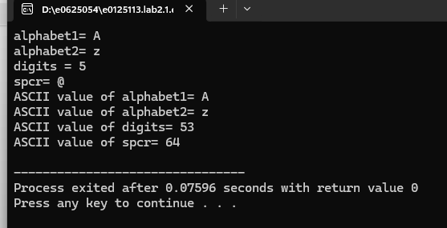

#include <stdio.h>
int main()
{
float wt,ht,bmi;
printf("please enter the weight of you in kilograms");
scanf("%f",&wt);
printf("please enter the height of you in meters");
scanf("%f",&ht);
bmi=wt/(ht*ht);
printf("your bmi is: %.2f\n",bmi);
return 0;
}
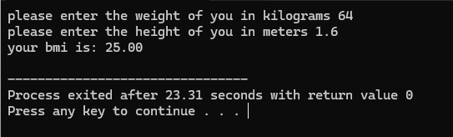
#include <stdio.h>
int main()
{int number1,number2;
printf("Enter the two numbers: ");
scanf("%d %d",&number1,&number2);
if (number1>number2)
{printf("The maximum number is:%d\n",number1);}
else
{printf("The maximum number is:%d\n",number2);}
return 0;}
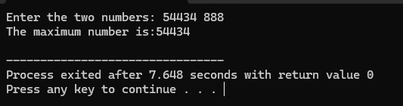
#include <stdio.h>
int main() {
int age;
char isCitizen;
printf("Enter your age: ");
scanf("%d", &age);
printf("Are you a citizen? (yes/no): ");
scanf(" %c", &isCitizen);
if (age >= 18 && (isCitizen == 'y' || isCitizen == 'Y')) {
printf("\nYou are eligible to vote.");
} else {printf("\nYou are not eligible to vote.");}
return 0;}

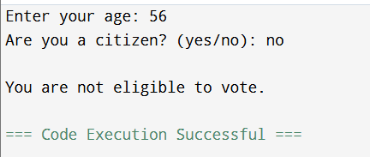

#include<stdio.h>
int main ()
{ int n1, n2, n3;
printf("\nenter the 3 numbers: ");
scanf("%d,%d,%d", &n1, &n2, &n3);
if (n1>=n2&&n1>=n3) {printf("the first number is the lagest");}
else if(n2>=n1&&n2>=n3) { printf("the second number is the largest");}
else {printf("the third number is the largest");}
return 0;
}
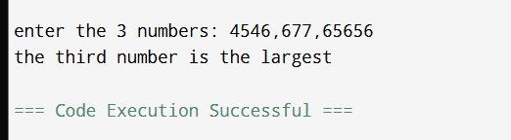

#include<stdio.h>
int main(){
int n;
printf("enter the value of the number:");
scanf("%d",&n);
if (n>0)
{ printf("the number is positive.");}
else if (n<0) { printf("the number is negative");}
else {printf("the number is zero ");}
return 0;
}
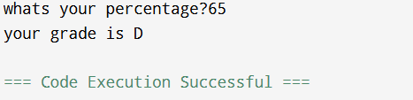

#include<stdio.h>
int main (){
int p;
printf("whats your percentage?");
scanf("%d",&p);
if (p>90) {printf("youru grade is A");}
else if (p>80) {printf("your grade is B");}
else if (p>70) {printf("your grade is C");}
else if (p>60) {printf("your grade is D");}
else {printf("your grade is F");}
return 0; }
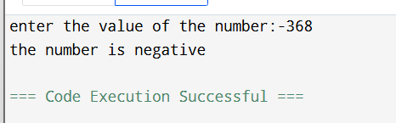#include <stdio.h>
int main() {
int VN;
printf("Enter the your vehicle number: ");
scanf("%d", &VN);
if (VN < 0001 || VN > 9999) {
printf("Invalid vehicle number. Please try again.");return 1;}
if (VN%7==0) {printf("its Free of cost for your vehicle");}
else if (VN%2==0 && VN%8==0) {printf("Pay half of the fee");}
else {printf("you have to pay the full fees");}
return 0;}
